UDACITY

**Introduction to Generative AI with AWS Project Documentation Report**

Visit [UDACITY Introduction to Generative AI with AWS Project Documentation Report](https://docs.google.com/document/d/1kqRy-gVGZjwl9r03hqMeWSm-D6hEY8KWuxz4GO0vdOw/copy) to make a copy of this document.

Complete the answers to the questions below to complete your project report. Create a PDF of the completed document and submit the PDF with your project.

Screenshot of the Model_FineTuning.ipynb file with the cell output of the input: “Outline the key aspects of ubiquitous computing from a data management perspective.”

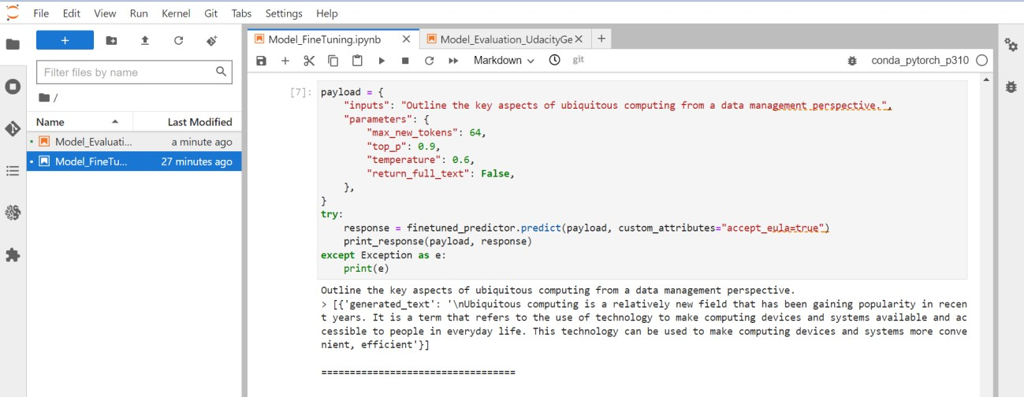

Screenshot of the Model_FineTuning.ipynb file with the cell output of the input: “A second important aspect of ubiquitous computing environments is”.

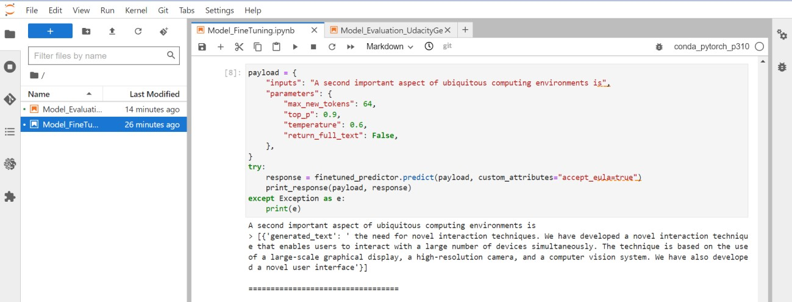

Screenshot of the Model_Evaluation_UdacityGenAIAWS.ipynb file with the cell output of the input: “Outline the key aspects of ubiquitous computing from a data management perspective.”

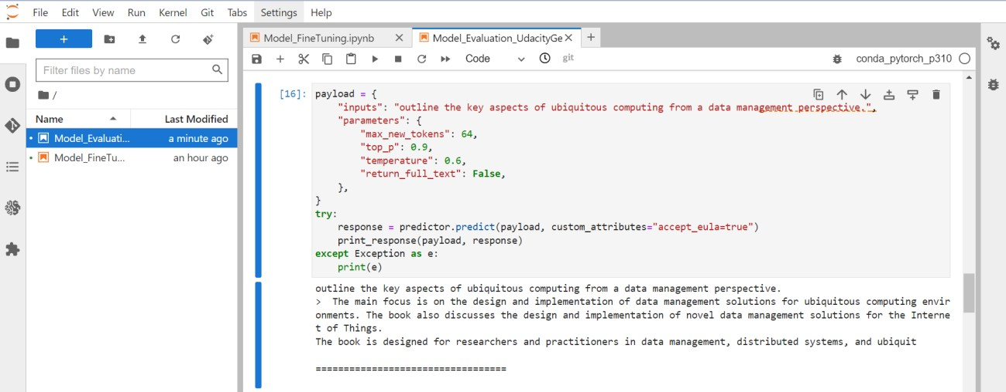

Screenshot of the Model_Evaluation_UdacityGenAIAWS.ipynb file with the cell output of the input: “A second important aspect of ubiquitous computing environments is”.

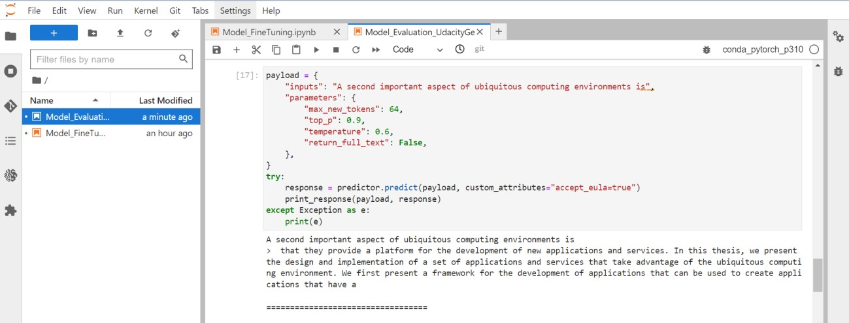

Screenshot of the Model_FineTuning.ipynb file with the cell that delete the model deployment and endpoint runned.

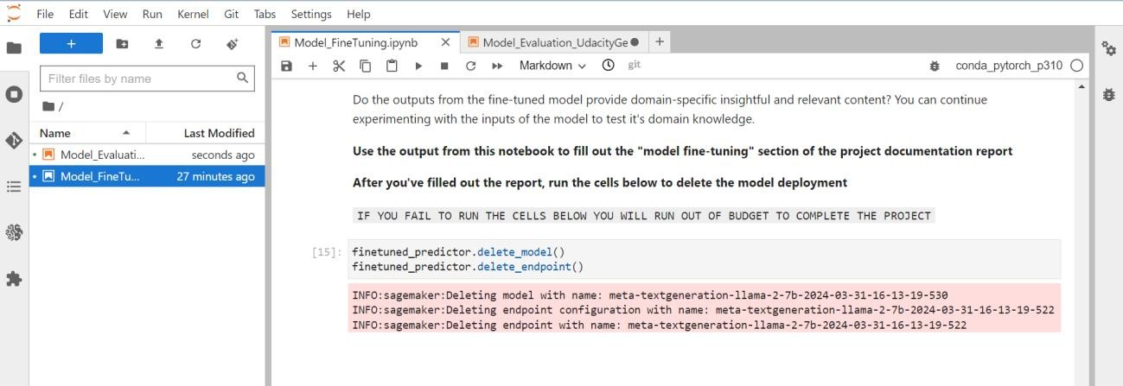

Screenshot of the Model_Evaluation_UdacityGenAIAWS.ipynb file with the cell that delete the model deployment and endpoint runned.

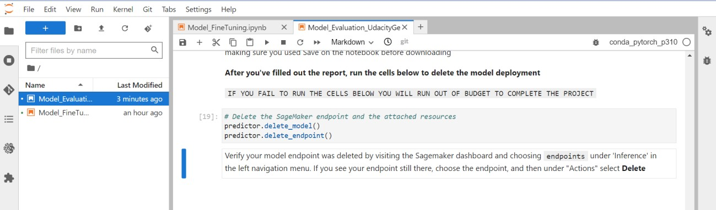

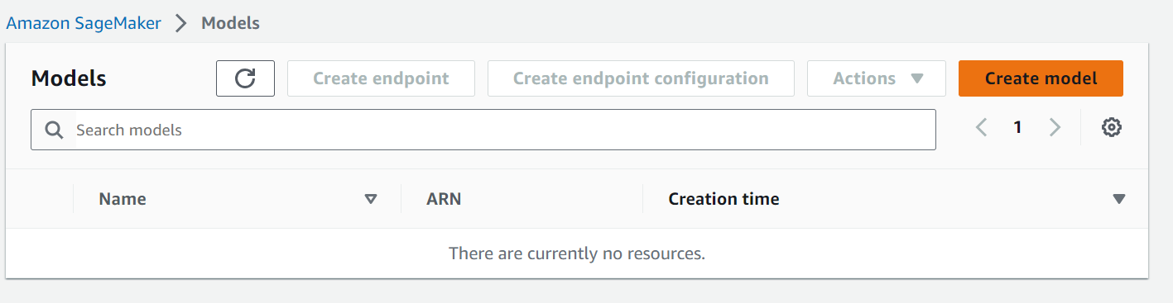Screenshot of verification of the model has been deleted.

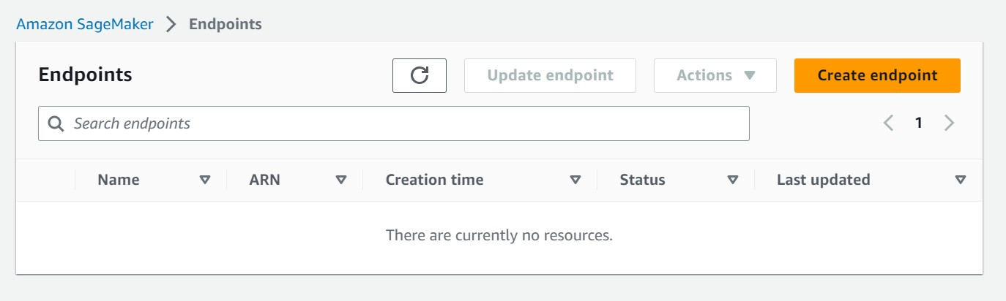Screenshot of verification of the endpoint has been deleted.